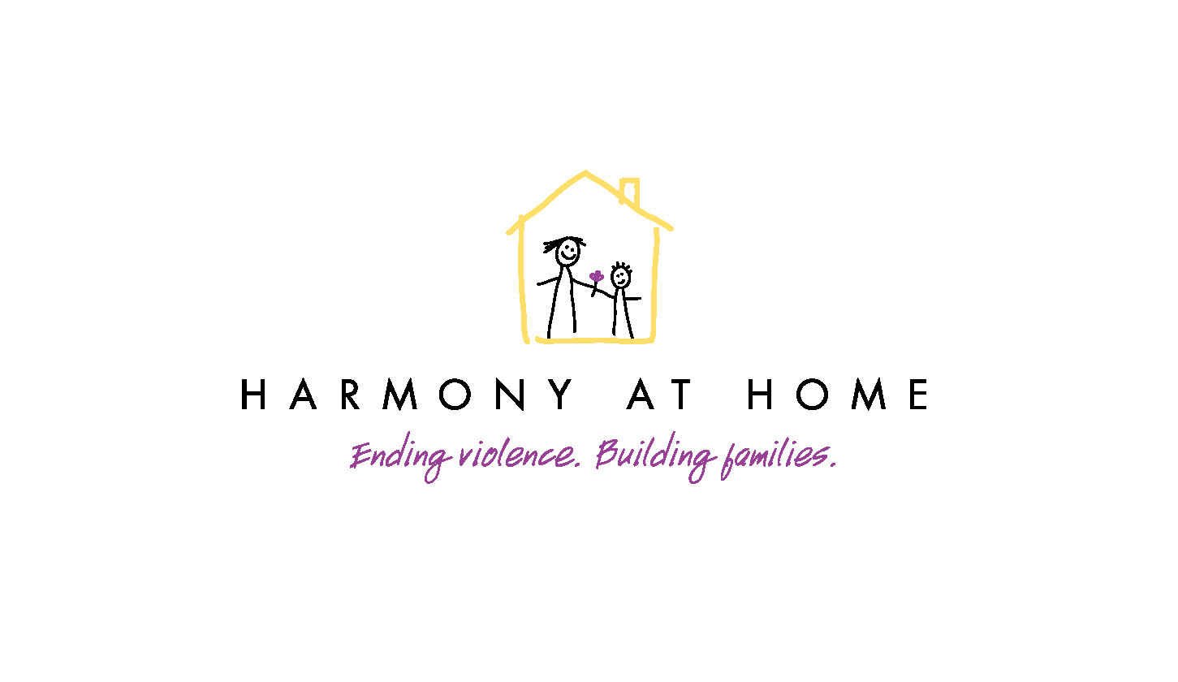
Harmony At Home
3785 Via Nona Marie, Suite 300, Carmel CA 93923
(831) 625-5160
julianne@harmony-at-home.org
www.harmony-at-home.org

Events that can lead to an experience of childhood trauma:
- An unstable or unsafe environment
- Separation from parent (foster care, death, divorce, jail, etc.)
- Serious illness (self, friend, or someone in family)
- Intrusive medical procedures (surgeries, chronic disease, ongoing treatments)
- Sexual, physical, or verbal abuse
- Domestic violence
- Exposure to gang violence
- Exposure to drug and/or alcohol abuse
- Neglect (physical or emotional)
- Extreme poverty
- Bullying

Some emotional and physical symptoms of trauma:
- Extreme shyness, quietness, or non-engaged with peers
- Extreme hyperactivity, disruptive behavior
- Physical symptoms of shock—stoic appearance, disconnected
- Flat affect—“no sparkle in the eyes”
- Depressed mood
- Expression of anger, shame, and/or self-blame
- Expression of feelings of sadness or hopelessness
- Signs of confusion, difficulty concentrating
- Expressions of anxiety, fear, shock
- Feeling disconnected, numb, or withdrawn
- Sleeplessness, poor sleeping habits, ongoing fatigue
- Outward appearance
- Overly sensitive to noise, crowds, or gentle touch; easily startled
- Describes ongoing aches, pains, or displays physical signs of concern
- Difficulty concentrating in school
- Difficulty making friends or keeping friends

